

## Small is beautiful but big is necessary

Speech given by

Minouche Shafik, Deputy Governor, Markets & Banking

Bloomberg markets most influential summit, London 28 September 2016

The title of this speech is an expression used by Sir Fazle Abed, the founder of BRAC, the largest non-governmental organisation in the world. He was referring to the development community’s fascination with small projects rather than focussing on large scale systemic change. In response he built an organisation that reaches over 100 million people, provides loans to five million poor women, and runs 40,000 schools.

I am especially grateful to Grellan McGrath, whose combination of creative challenge, analytical depth and organisational skills greatly enhanced this speech. I would also like to thank Ben Morley, Lee Robinson and Alastair Firrell for their assistance. I am grateful to other Bank of England staff and fellow members of the policy committees on which I sit for helpful comments on an earlier draft.

Nevertheless, the view expressed are my own and not necessarily those of the Monetary Policy Committee, the Financial Policy Committee or the Board of the Prudential Regulation Authority.

Check against delivery.

#### Introduction

Central banks are bigger than ever before. Gone is the pre-crisis ideal of minimalist central banks with small balance sheets, narrowly defined objectives and tools, and a bias toward non-intervention. Today, major central banks have greater responsibilities and a wider range of tools at our disposal. Our balance sheets are larger and for the most part continuing to increase (Chart 1). I’d like to use these remarks to offer a number of reflections on these developments, using the Bank of England’s recent experience by way of example, and focussing on four themes.

My first theme is that the broadening of our responsibilities and range of tools at our disposal has facilitated a more joined up approach to how we set monetary policy and pursue financial stability – as I will illustrate using the example of our contingency planning around the referendum. Second, the increase in size of our balance sheet has been a necessity of the times we live in. Deep structural forces have combined to depress the level of interest rates at which the economy would be in equilibrium, obliging us to rely evermore on monetary policies that were once considered unconventional. This requires us to operate with multiple instruments in multiple markets meaning that our impact on the financial system – the central bank’s footprint

– is larger.

Third, we are aware that some of our policies have spillovers and side effects, but we take steps to address them where feasible to do so within our mandate. We know that a bigger footprint means we need to be mindful of our step. Finally, despite our bigger size, there are some things central banks cannot do. To generate sustainably strong growth over the medium term, monetary and financial stability policy must be part of a balanced package that also includes the government’s economic policies and, given strong global interconnections, international policy co-ordination.

#### Joined up contingency planning

I’ll start with our contingency planning prior to the referendum on the UK’s membership of the EU. We started from a position of strength thanks to changes made since the financial crisis, including: reform of the regulatory capital and liquidity frameworks; a more robust supervisory model; and increased access to our own liquidity facilities. Nevertheless, as we made clear in the run up to the vote, the three statutory committees on which I sit – the Monetary Policy Committee (MPC), the Financial Policy Committee (FPC), and the Prudential Regulation Authority (PRA) Board - undertook extensive work to consider the implications of a vote to leave the EU.

This contingency planning was the embodiment of joined up policymaking. The MPC and the FPC met to exchange views on risks around the referendum for financial and economic conditions; the FPC and the PRA Board both considered the potential for the referendum to create financial instability; supervisory and market operations staff worked in tandem to ensure that banks’ liquidity needs could be met through a prudent

combination of their own buffers and Bank of England facilities; and we made sure to reach out to our international partners in order to be able to present a co-ordinated response whatever the result of the vote.

I am sure that everyone in this room could tell similar stories of detailed and co-ordinated contingency planning in firms across the UK and indeed internationally. In part because of this careful planning by all of us, the day after the referendum was remarkably orderly. Like many of you, I arrived in a dealing room in the very early hours of the 24th of June to witness astoundingly large volumes go through the foreign exchange market in a remarkably orderly fashion as sterling found its new level - many banks and trading platforms reported turnover that was up to ten times the typical daily amount. And, like many of you, I went through a series of pre-scheduled conference calls and meetings with market participants and counterparts in the international system which had an eerily calm atmosphere as the immediate risks we had most feared – thankfully - did not materialise.

That is not to say there was nothing to do. Having raised the countercyclical capital buffer in March, the FPC was in the welcome position of being able to reduce it once again and thus send a strong signal that banks would be expected to support lending to the real economy. And having already made clear that it would allow insurers to use the flexibility built into the transition to Solvency II, the PRA was able to re-iterate publicly that firms could apply for approval to re-calculate the Transitional Measures on Technical Provisions as at the end of June – thus reducing the impact of the sharp decline in risk free interest rates on their solvency positions.

Given my responsibility for the Bank of England’s market operations, one success story I will draw particular attention to is the resilience of banks’ liquidity positions. By way of context, in the period since the financial crisis banks have increased their liquid asset buffers fourfold, and increased fourfold the lendable value of collateral pre-positioned for use in the Bank of England’s normal liquidity facilities. In recent years we have made much of these facilities and how they have been overhauled since the crisis to provide access to a broader range of counterparties, and to provide liquidity against a broader range of collateral.

But in truth this was one of the first times these new facilities had truly been put to the test, and I am pleased to say they performed admirably. The flexibility we were able to show by increasing the frequency of our regular operations gave added reassurance to banks that they would indeed be able to rely on us. Our ability to send the message to the wider public on the day of the referendum that we stood ready to lend more than

£250bn to the banking system helped head off any concern about the health of our banks. And the fact that the facilities were used in moderate size proved they are an effective form of insurance – over the month of June banks borrowed about £9bn of central bank reserves from us through our regular operations in exchange for pre-positioned collateral as they prudently maintained very high levels of liquidity around the referendum result.

#### Navigating through uncertainty

Once it became clear that the immediate financial stability risks had either not materialised or been effectively mitigated, our attention turned to the macroeconomy. In setting monetary policy after the referendum result, we faced two challenges. The first was that there was little data on which to base an assessment of how the outlook had changed; the second was that we started from the unusual position of Bank Rate already being at a record low. I’ll take each of these challenges in turn.

It is vital that monetary policy is set in a forward looking manner, given the lags in the transmission mechanism, and this means taking decisions even when the data cycle is at an early stage. That was very much the case in August. Although we had little hard economic data covering the period since the referendum, we did have some forward looking surveys and leading indicators of GDP growth at our disposal. Now these leading indicators are of varying quality – some have a high predictive content for GDP growth, others very little, so it can be difficult to know what signal to take.

One simple way of organising this information is illustrated in this “radar” of economic indicators which I found helpful to navigate through the data (Chart 2). Its cells are coloured green when the indicators are above their long run average; amber when they are below, which is cause for concern; and red when they are well below, which is even more worrying. The cells in the centre represent the data which have historically had the highest correlation with GDP growth, while those in the outer circles have a lower correlation with GDP growth and are less reliable.

The first radar dates from early 2014, a year in which GDP growth was 3.5%, so it is not surprising that its cells are predominantly green. The intervening years remained mostly green, though some amber spots began to appear as the initial recovery slowed to a more normal rate of expansion. In the wake of the referendum result, at the time of our decision in August, the most reliable indicators – those at the centre – were for the most part flashing amber or red (Chart 3). Since then, of course, the data have turned out more positively than expected, and the radar has become a little less red, a little more amber, though it mostly remains below average levels (Chart 4).

Now, this is just a way of organising the data. Formally extracting a signal from it requires much by way of econometrics – there is a rich literature devoted to data uncertainty and nowcasting, to which the Bank has contributed significantly1. Forward looking indicators are prone to overreaction and in some cases are outright misleading. Moreover, their predictive power is limited to the very near term outlook. Given that monetary policy has its greatest effect one to two years ahead, this means we must combine our

1 The Bank currently uses several nowcasting models to predict the current rate of GDP growth. Details of some of these models can be found here: [http://www.bankofengland.co.uk/publications/Documents/quarterlybulletin/2014/qb14q106.pdf.](http://www.bankofengland.co.uk/publications/Documents/quarterlybulletin/2014/qb14q106.pdf) Initial estimates of GDP growth get revised over time, so the Bank makes distinct predictions for ‘preliminary’ and ‘mature’ estimates of GDP growth. More details can be found here: <http://www.bankofengland.co.uk/publications/Documents/quarterlybulletin/qb070301.pdf>

assessment of the near term indicators with a view of the underlying shocks which will drive the economy over the coming years.

There is no doubt in my mind that the UK is experiencing a sizeable economic shock in the wake of the referendum. Any reduction in openness or need to reallocate resources will necessarily imply a slower rate of potential growth for the economy. Moreover, the reality of the protracted process of withdrawing from the EU means we still know very little about the nature of our future trading arrangements, and this uncertainty is weighing on prospects for business investment. Our agents around the country report that some new projects are being scaled back or deferred until the outlook becomes clearer. There are signs that foreign companies have become more cautious about investing in the United Kingdom, and we know that some of those who rely on the European Union as a destination for their exports are beginning to make contingency plans in case they have to move some of their business elsewhere.

All of this reflects the unavoidable economic reality of a period of transition. The depreciation of the sterling exchange rate is certainly helping the economy find a new equilibrium. While the flexible nature of the UK economy means it will ultimately adjust to its new circumstances, the process of adjustment can sometimes be painful. That’s where monetary policy can help, and it seems likely to me that further monetary stimulus will be required at some point in order to help ensure that a slowdown in economic activity doesn’t turn into something more pernicious.

However, the likely timing of that stimulus will depend on the continued evolution of the data over the coming weeks and months. Thus far, the welcome improvement in the forward looking indicators suggests that the slowdown may not be as sharp or as sudden as we might have feared. For example, Bank staff have revised up their forecast for the mature estimate of GDP growth in Q3 to 0.3% from 0.1% at the time of the August Inflation Report. But we will learn a lot from the arrival of more official data for the post-referendum period, and that will allow us to navigate by looking out the window as well as down at our radar.

#### A package tailored to our starting point

What is unusual about this particular loosening relative to previous cycles is its starting point. Despite many real economic variables having returned to around normal levels following the financial crisis the absence of any signs of overheating or inflationary pressure meant that at the time of the referendum Bank Rate was already at an all-time low of 0.5% and we held a stock of £375bn gilts on our balance sheet.

The global decline in market-based measures of long run real interest rates - which have fallen by more than 5 percentage points since the 1980s (Chart 5) – suggests that the neutral rate of interest is now far lower than any time in the past.2 The drivers behind this move are deep structural shifts in trend growth rates,

2 Carney (2013) Haldane (2015), Rachel and Smith (2015), Shafik (2015a)

demographics and risk appetite. Taken together, they have changed the global balance of savings and investment, thus depressing the level of interest rates which will bring the economy into equilibrium.

These structural factors are beyond the influence of monetary policy. We can only respond by setting Bank Rate lower than in past economic cycles - to do otherwise would result in an unwarranted slowing of

the economy. It means we must consider carefully where we think the effective lower bound in our policy rate is – taking into account financial stability considerations. It also means that we must be ready to use monetary policy instruments other than Bank Rate – what was once unconventional is increasingly becoming conventional.

With that in mind, the MPC had actively considered in the run up to the referendum how we would go about loosening if it was necessary. Working closely with supervisors in the PRA we confirmed that we had room to lower Bank Rate to a small positive number without endangering the banking system. Based on our continuous dialogue with the Debt Management Office and market participants, we knew there was scope to buy more gilts. We also confirmed that there were a number of additional tools that we could use to generate economic stimulus. In fact our creativity was limited only by the number of combinations and calibrations the nine members of the MPC could come up with – making the voting process a bit like trying to solve a Rubik’s cube.

The package the MPC ultimately chose had five elements: a cut in Bank Rate to 0.25%; the launch of a Term Funding Scheme (TFS) to reinforce the pass through of that cut; the purchase of up to £10bn of corporate bonds; the purchase of an additional £60bn of gilts; and forward guidance that should the data prove to be broadly consistent with the August Inflation Report forecast, a majority of members expected to support a further cut in Bank Rate during the course of the year. A sixth element was added by the FPC, who in parallel approved a change to the definition of the leverage ratio to exclude central bank reserves, thus making our monetary policy package more effective.

This package involved several pieces of innovation for the Bank of England. It brought our official policy rate

to a new record low in the Bank’s 322 year history. It will bring the stock of government bonds on our balance sheet up to £435bn, representing 23% of nominal GDP, a new high. For the first time, we will purchase private sector assets for monetary policy purposes3. And we will lend central bank reserves to the banking system, at a rate close to Bank Rate, for a longer term than ever before.

3 The Bank has previously purchased private sector assets, via the Asset Purchase Facility, in order to help improve market liquidity in credit markets that are not functioning normally. For example, the Corporate Bond Secondary Market Scheme offered to make regular small purchases and sales of corporate bonds from 2009 until 2013, when it was moved to operating only if warranted by market demand. Since there was no indication of demand in the intervening period, the scheme was closed in August 2016. More information is available at <http://www.bankofengland.co.uk/markets/Pages/apf/withdrawnschemes/default.aspx>

#### Mindful of our step

The reason the MPC took these actions is because they will benefit the economy and, by delivering monetary stability, contribute to prosperity. Our initial assessment of the impact so far has been positive. But we are very aware that all monetary policy has spillovers and side effects, and that we have a duty to minimise those where it is possible to do so without jeopardising the overall beneficial impact. With that in mind, I would like to discuss three criticisms frequently levelled at monetary policy of this kind, and to illustrate how the MPC tried to take them into account.

1. *Ultra low interest rates are self-defeating because banks are unable to pass them through to customers.* This criticism has its genesis in the fact that once household and business deposit rates have reached a very low level, it becomes difficult for banks to reduce them further. They face a choice between not passing the change in Bank Rate through to borrowers, or having their net interest margins squeezed.

In light of the mixed experience of pass-through of very low levels of policy rates by other central banks, this was something the MPC was acutely aware of in deciding how far it should reduce Bank Rate. Using the intelligence and analysis of bank supervisors in the PRA, we were able to establish that net interest margins on banks’ UK retail business were sufficient to comfortably withstand a cut in our policy rate to a small positive number. UK banks’ Net Interest Margin were around 230bps in 2015 on average (Chart 6).

However, we still faced the risk that banks would choose to preserve these existing margins, dampening the pass through of our change to rates faced by households and consumers. The TFS is explicitly designed to counter that risk to the transmission mechanism by tethering banks term funding costs more closely to our policy rate. It gives them the ability to borrow from us for up to four years at Bank Rate so long as they maintain their lending to the real economy. The initial signs are good - standard variable rates have already been or, we expect, shortly will be reduced on the vast majority of existing mortgages, and the rates available on new lifetime tracker mortgages are on average 25bps lower.4 5 Though it is of course difficult to say how much of this is directly attributable to the TFS.

1. *Quantitative Easing has adverse consequences for pension funds and insurance companies.* The MPC is very aware that the marginal impact of low long term risk free interest rates is – all else equal

– to increase the present value of pension fund liabilities, and to increase the margin that insurers must set aside to cover the present value of otherwise unhedgeable risks. This is something we hear

4 Based on announced changes and supervisory intelligence on changes to Standard Variable Rates by 19 lenders representing 90% of the stock of Monetary Financial Institutions’ lending, weighted by their share in the value of outstanding mortgages.

5 Based on the Bank’s quoted rates data on new Lifetime Tracker mortgages.

frequently through our Market Intelligence, from businesses we meet, in conversations with the Pensions Regulator, and of course through the PRA’s prudential supervision of insurers. It is also an international concern since long rates are low globally.

Ultimately, the way the MPC can most effectively contribute to generating the stable return on assets that these investors need to meet their long term liabilities is by supporting stable economic growth and by pursuing its inflation target. The boost to economic activity that will come with lower interest rates should increase the profits of companies across the country, and boost the value of financial assets more generally. Indeed for a pension scheme that starts off in balance, the increase in value of assets can be expected to offset the increase in liabilities.6 The problem arises for pension funds that already start from a deficit, who will find it more costly to acquire the assets to match their future liabilities.

In making our policy decisions we must bear in mind we are uncertain about the magnitude of both the impact of QE on the economy and its side effects. Indeed that was one of the key motivations in working to develop a broad range of tools. At the margin, our determination to use a range of easing options – rather than relying solely on the purchase of gilts – likely reduced the marginal impact on long term risk free rates. Our package spread the transmission of monetary policy more evenly across short-term interest rates, corporate credit and bank funding markets, as well as long rates.

Conscious of the structural changes in market liquidity over recent years7, we are also purchasing at a slow pace compared to previous rounds of quantitative easing to minimise any impact on market liquidity (Chart 7).

1. *The central bank should not take the place of private markets in allocating credit.* The need to avoid unduly affecting the allocation of credit was paramount in our design of the corporate bond purchase scheme. As a result, we have deliberately chosen criteria for purchases that will give us a broad and representative range of issuers and sectors. Those companies who have an investment grade rating, subject to assessment by our risk management staff, and who make a material contribution to the UK economy can expect their bonds to be eligible.8 Purchases began yesterday, and at the end of each month we will publish our holdings in each of 9 sectors, and how that compares to the corresponding market share. Over time, we will adjust our purchases with the aim of achieving a sectoral balance across our portfolio that matches that of the market as a whole.
2. See Bean (2012) for illustrative scenarios of the impact on pension funds with different initial positions.
3. Shafik (2015b), Cunliffe (2015)
4. Eligibility decisions will be made by our risk management staff, taking into account a number of different factors. Eligible companies

may be incorporated in the UK or other jurisdictions. Companies with significant employment in the UK or with their headquarters in the UK will normally be regarded as making a material contribution to the UK economy. We will also consider whether the company generates significant revenues in the UK, serves a large number of customers in the UK or has a number of operating sites in the UK. For example, a company headquartered outside of the UK but employing hundreds of people in the UK and generating sales of £20m in the UK would be considered to make a material contribution to the UK economy.

#### Things a central bank cannot do

I hope I have by now convinced you of three things: (i) that the benefit of gathering a broad range of responsibilities under one roof allows us to practice more effective joined up planning and policymaking (ii) that the expanding size of the Bank of England’s balance sheet is a necessary response to the circumstances we find ourselves in (iii) that in making decisions we are conscious of the spillovers of our actions.

Let me end on a note of humility. If I were to be granted one wish as a central banker it would be to increase the neutral rate of interest toward a more historically normal level. That would hasten our return to a simpler world in which Bank Rate would be our only monetary policy tool, and allow us to reduce our footprint in other financial markets accordingly and return to a “small is beautiful” world.

However, despite the broadening of our responsibilities and the increase in tools at our disposal, the

Bank of England does not set the neutral rate of interest – that is set by the economy. Over the long run, it is determined by deep structural forces, including demography, the flexibility of our labour and product markets, the quality of our institutions and infrastructure, and the balance of savings and investment in the world economy. Policies that affect those forces can increase the potential growth rate of the economy, and lead to a general improvement in the underlying appetite for investment, thereby driving up interest rates.

So monetary policy is just one part of the story alongside government’s fiscal and structural policies and the degree of international policy co-ordination. A good balance between them can put us on a more prosperous and stable path. But for now, even if we might wish for the time when small was beautiful, big is necessary.

#### References

**Bean (2012)** “Pension Funds and Quantitative Easing,” *Speech given to the National Association of Pension Funds’ Local Authority Conference.*

**Carney (2013)** “The Spirit of the Season,” *Speech given to the Economic Club of New York*.

**Cunliffe (2015)** “Market Liquidity and Market-Based Financing,” *speech given at the British Bankers Association International Banking Conference, London.*

**Haldane (2015)** “Stuck,” *Speech given at the Open University, Milton Keynes*.

**Rachel, L. and Smith, T. (2015)** “Secular Drivers of the Global Real Interest Rate,” *Bank of England Staff Working Paper No. 571.*

**Shafik, M (2015a)** “Interpreting the Yield Curve: Warning or Opportunity?” *Speech given at the Association of Corporate Treasurers Annual Conference, Manchester.*

**Shafik, M (2015b)** “Dealing with change – Liquidity in Evolving Market Structures,” *Speech given at AQR Asset Management Institute, London Business School.*



## Small is beautiful but big is necessary

### Minouche Shafik, Deputy Governor for Markets and Banking At the Bloomberg Markets Most Influential conference

28th September 2016

**Chart 1 – Central bank balance sheets are bigger and**

**continuing to increase**

Per ce 125%

of GDP 60%

100%

50%

40%

75%

30%

50%

20%

25%

10%

0%

2006 2008 2010 2012 2014 2016

0%

2018

#### Sources: Bank of England, Federal Reserve, Bank of Japan, European Central Bank, Bloomberg, ONS and Bank calculations.

nt of GDP

Per cent

Bank of England (RHS) Federal Reserve (RHS) ECB (RHS)

Bank of Japan (LHS)

Forecast

Note: For the Bank of England’s balance sheet, projections are consistent with £60bn of gilt asset purchases over 2 quarters; corporate bond purchases of £10bn over 18 months commencing in September; and TFS usage of £100bn over 18 months.

**Chart 2 – In early 2014 leading indicators were consistent with**

**above average growth**

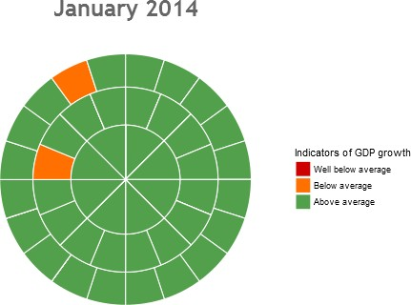

**Chart 3 – In August 2016 indicators with the highest correlation with GDP growth were mostly below or well below average**

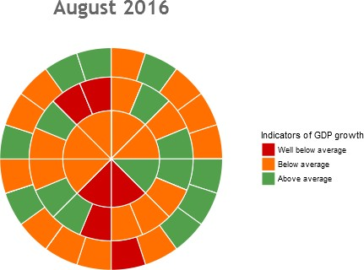

**Chart 4 – Some indicators with the highest correlation to GDP have improved but most remain below average**

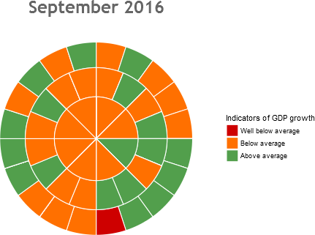

**Chart 5 – Real and nominal yields on long-term government**

**bonds have been declining over the course of decades**

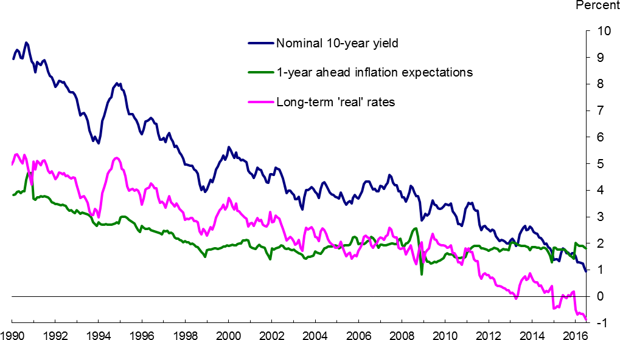

#### Sources: IMF, DataStream, Consensus Economics & Bank calculations

Notes: Blue line shows the GDP-Weighted average of 10-year sovereign yields for 20 advanced economies (G7, Australia, Austria, Belgium, Denmark, Finland, Ireland, Netherlands, New Zealand, Norway, Portugal, Spain, Sweden, Switzerland). Green line uses 1-year ahead inflation expectations from Consensus Economics as a proxy for 10-year inflation expectations for each country (again GDP- weighted together). The pink line simply shows the difference – so this measure of real rates does not take account of changes in risk premia.

# Chart 6 – UK banks’ net interest margins have remained broadly stable in recent years

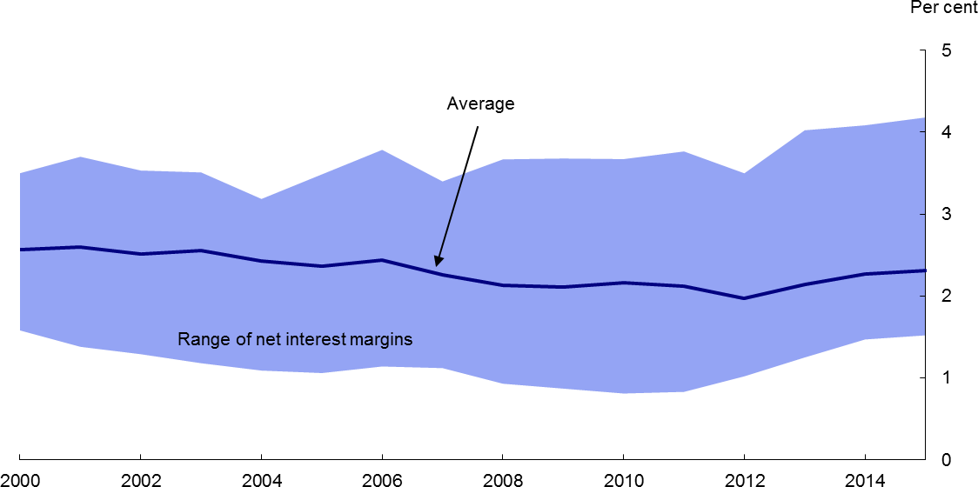

#### Sources: Published accounts and Bank calculations

**Explanatory note:** Estimates derived from published accounts for the six largest UK banks: Barclays, HSBC, Lloyds Banking Group, Nationwide, Royal Bank of Scotland and Santander UK. the definition of net interest margin used differs by bank and over time, as the calculation is not prescribed under International Financial Reporting Standards.

# Chart 7 – The MPC has deliberately chosen a slow pace of purchases relative to previous rounds of QE

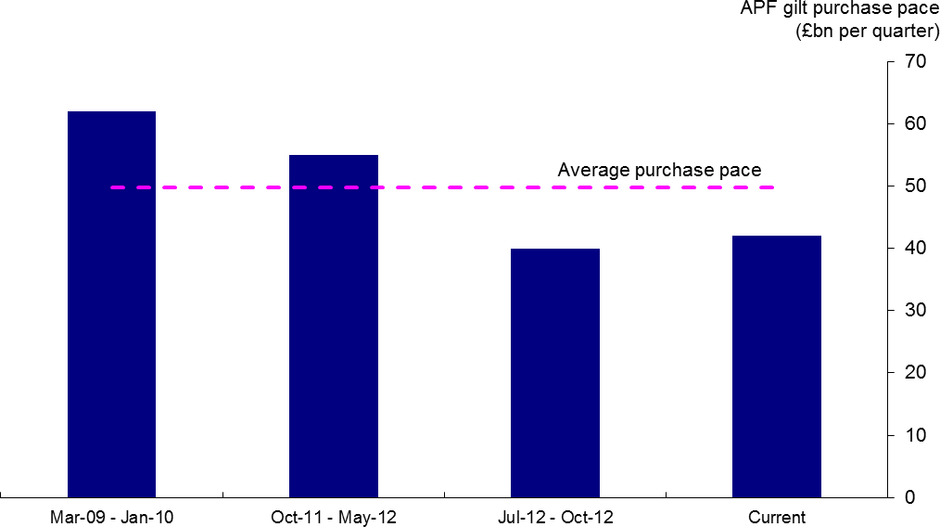

#### Source: Bank of England



**Small is beautiful but big is necessary**

Minouche Shafik, Deputy Governor for Markets and Banking At the Bloomberg Markets Most Influential conference

28th September 2016